Hosting possibilities for volunteers in KERIC in 2011

Host organisation: KERIC
EI reference number: 2010-SK-29
Address: Nabrezna 1351, 022 01 Cadca, Slovakia
Website: www.keric.sk
Contact for EVS: Ivana Hruskova, ivka@keric.sk; +421 908 913 994

KERIC is a host, sending and coordinating organisation for EVS. We have been involved in EVS since 2003 and until now we have hosted over 50 volunteers and have sent an approximately the same number of volunteers abroad. During this time we have developed good contacts within the local community with other organisations who wish to be involved in EVS. Therefore, we have decided to involve the volunteers hosted by KERIC in our partner organisations as well.

All the projects that we offer are run by KERIC but the level of involvement in the activities of the organisation itself is different. Some volunteers will be based in KERIC, others will partly cooperate with KERIC and partly with our partner organisations. The details of each project are described below.

Teaching languages + organising workshops for children
Location: | Cadca, host organisation KERIC | 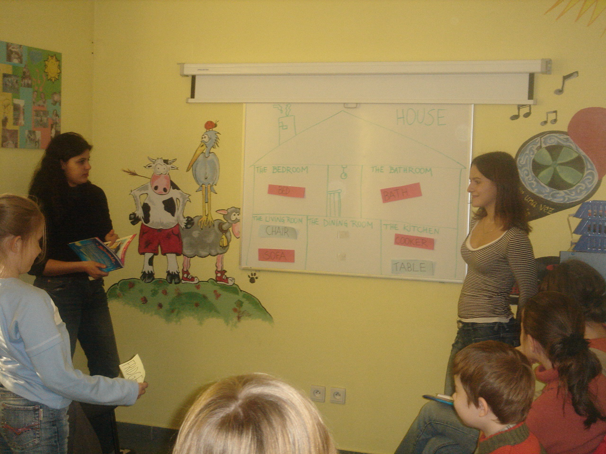
Theme of the project | European awareness, non-formal education
Number of contemporary placements | 4
Duration of activities in months | 10-12
Start of activities | September 2011
Accommodation: | a flat shared with the other volunteeers in a housing estae in Čadca
Description of activities: | The volunteer will be involved in activities with children and youth - leading language courses, doing creative workshops, leisure time activities, leading summer camps, etc.  We usually host 6 to 8 volunteers from different countries of Europe and Latin America at the same time.  The volunteers will start EVS in September 2011, prefarably staying for 12 months, but 10 or 11 months is also ok.
Tasks of the volunteer | The tasks of the volunteers generally include: Regular schedule (mid-September to end of June): - Helping in conversation English course for children (2 to 6 hours a week, lessons prepared and run together with a Slovak teacher) - Leading a conversation course for teenagers / adults in own language of the volunteer (between 2 to 6 hours a week, own class) - Creative activities for children and youth in KERIC Underground club or at partner organisations (between 1 to 8 hours a week, choice of activities is up to the volunteer – music, arts, sports… , activities are run independently or together with other volunteers) - Workshops and support work at local elementary school (between 1 to 2 mornings a week, choice of subjects and activities upon agreement between the volunteer and his/her contact person at school) - European workshop (approx. two mornings a month, presentation of own country in a non-formal way, games, discussions, presentation of own activities and EVS) - Street campaings, concerts, promotion activities – approximately once in every four months - help to run KERIC – small daily chores when needed - administration work, cleaning, looking after the building, etc.) - the volunteer will be involved in youth exchanges, international seminars and trainings organised by KERIC or by partners of KERIC abroad Summer schedule (July and August): preparation and running of summer camps, sailing trips and daily camps for children The schedule of each volunteen will be discsussed with him/her in detail and exact personal schedule will be adjusted
Selection criteria | The interested volunteers are expected to send a motivation letter and CV.  The volunteers are expected to have:  - interest in work with children and youth  - interest in foreign languages and in teaching languages  - enthusiasm, creativity and responsibility
Reference on the project | www.en.keric.sk - Experience EVS

Open air Museum

Location: VYCHYLOVKA – 30 min. by bus from Cadca | Accommodation: chalets, Stará Bystrica, daily transport to Vychylovka by bus
Number of contemporary placements | 2
Duration of activities in months | 6
Start of activities | May
Description of activities:

Working days in museum – Thursday to Sunday are working days, Monday – working meeting and Slovak lesson, Tuesday and Wednesday are days off

The volunteer will do his/her project in an open-air museum Vychylovka. The museum consists of houses typical for
The tasks of the volunteer include:
- renovation of the exhibits and traditional railway
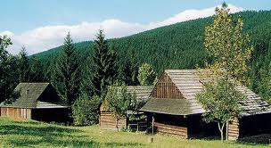
- maintenance of the exposition
- general tasks connected with looking after the museum
- helping out the tour guides – if needed
- organisiging events and activities for school groups visiting the museum
- learning Slovak

More info: http://www.kysuckemuzeum.sk/index.php?option=com_content&task=blogcategory&id=82&Itemid=278

Centre for homeless people

Location: Cadca | Accommodation: Čadca
Activity field: | Social work with homeless people
Number of contemporary placements | 1
Duration of activities in months | 4
Start of activities | May
Description of activities:

The Organisation provides accommodation and support for homeless people. The homeless people can visit the centre and wash themselves there, find personal and heath care there. They also organise free time activities there (e.g. going for a walk, to the swimming pool, etc). The volunteer will be involved in every day life of the centre and help out in everyday tasks of the staff of the centre. The centre has 4 social workers employed full time and several Slovak vounteers. The centre closely cooperates with catholic church. Religious ..... is not a conditions for the vollunteer.

The activities of the volunteer include:

1. being present in the centre, dedicate time to the homeless people based on their need
2. helping the staff when going with the people from the centre to the swimming pool, for a walk, etc.
3. helping out in running workshops
4. street work – monitoring the squatters in the town, offering coffee and tea to homeless people in the town

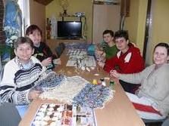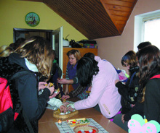

CADCA – EKO project

Location: Čadca | Accommodation: Čadca
Number of contemporary placements | 5
Duration of activities in months | 3
Start of activities | May
Description of activities:

KERIC is located nearby the river bank of the river Kysuca, which flows around the city. The area next to the river is often used by people from the city to go for walks or by mothers to walk withtheir children or babies in a pram. It is one of the very few places in the city which can be used by pedestrians. Unfortunately, the surroundings of the river bank is not maintained by anybody and the area is neglected and does not provide a welcoming surroundings for the pedestrians who go there for a walk. There are no facilities there – no playgrounds, sand pits, there are just a few banches to sit at one of the ends of the river bank. Therefore, KERIC would like to organised this short term project to clear the river bank and provide a welcoming space there for the pedestrians. The volunteers will cooperate with the city gardener and clear the river bank under his guidance. They are welcome to come up with own ideas how to improve the surroundings and to provide a welcoming atmosphere for the pedestrians. At the end of the project, the volunteers will organise an opening campaign of the river bank space The way this event will be organised is completely up to the volunteers. .KERIC will provide support for the volunteers to organise this event (contacts, financial sources, facilitations, etc.)

The tasks of the voluntees include:
- manual work – cleaning the river bank from rubbish, clearing it from wood, cutting the grass, etc.
- organising the opening campaign of the „new river bank“ at the end of the project
- information activities about EVS

Community work with children

Location: Cadca | Accommodation: Čadca
Number of contemporary placements | 1
Duration of activities in months | 10
Start of activities | September
Field of action | Education trhough sport and outdoor activities
Description of activities:

There is a sports area that can be used by the children from the local community in the afternoon for sports. The area is accessible to anybody. There is a basketball, football and multifuncitional playground in the area. A regular worker (caretaker) is responsible for the playground, the volunteer will be a support for him. The work will involve mainenance of the playground (manual work like cutting the grass, cleaning the area, etc.) as well as informal education of the children who come to the playground in the afternoon.
This means that the volunteer will help to run the sports activities in the playground, facilitate the children, play with them volleyball, football and other games for children and maintains the playground. Other tasks of the volunteer might involve conversation clubs in own language, workshops for the children, helping out in classes in the local school and learning Slovak .
The aim of the project is that in an informal way, through sports and personal contact with the children, the volunteer gets involved in the community.

Strong motivation to learn Slovak is expected from the volunteer.

The volunteer must be prepared for:
- prejudice
- language barrier
- unwillingness of children to cooperate

